# **Phase 6 – User Interface Development**

## **1. Introduction**

This phase designs the **user-facing interface** of the Punjab Flood Relief CRM. It ensures NGO admins, donors, and volunteers can interact with the system easily through Home Pages, Record Pages, Tabs, Utility Bar, and Lightning Web Components (LWCs).

## **2. Create Lightning App (ReliefConnect CRM)**

Navigate: Setup → Quick Find → App Manager → **New Lightning App**

* App Name: ReliefConnect CRM
* Developer Name: ReliefConnect_CRM
* Description: Disaster Relief & Donation Management CRM
* Navigation: Standard Navigation with Tabs

Add tabs for: Donors, Donations, Volunteers, Relief Requests, Distributions

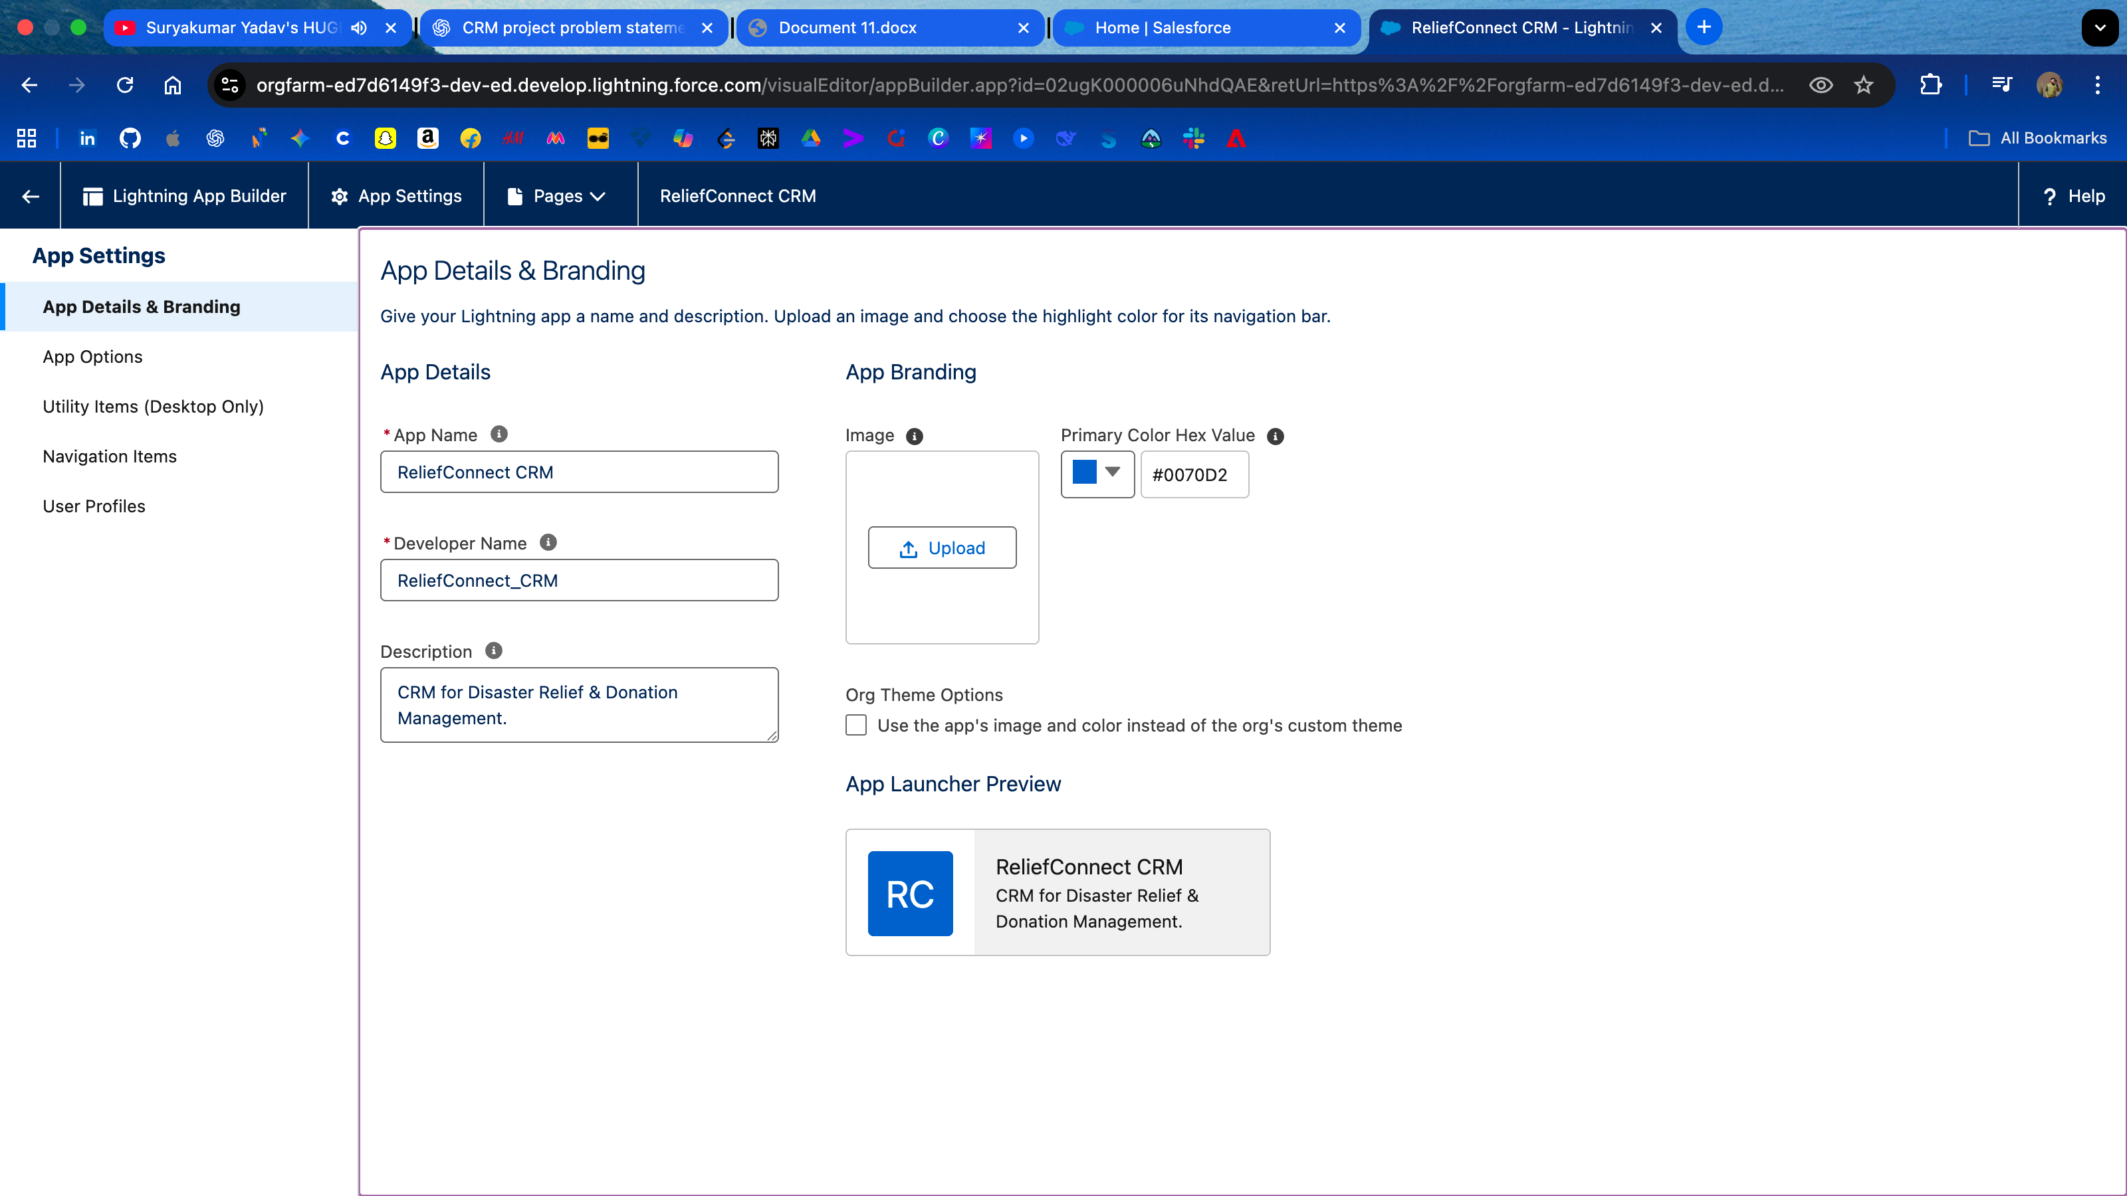

## **3. Lightning App Builder – Home Page**

Navigate: Setup → Lightning App Builder → **New Page → App Page**

* Name: *ReliefConnect Dashboard*
* Template: Header and Three Regions
* Components to add:
  + Rich Text → Heading: “Punjab Flood Relief Dashboard”
  + Report Chart → Donations by Type
  + List View → Relief Requests
  + List View → Volunteers
* Save & Activate

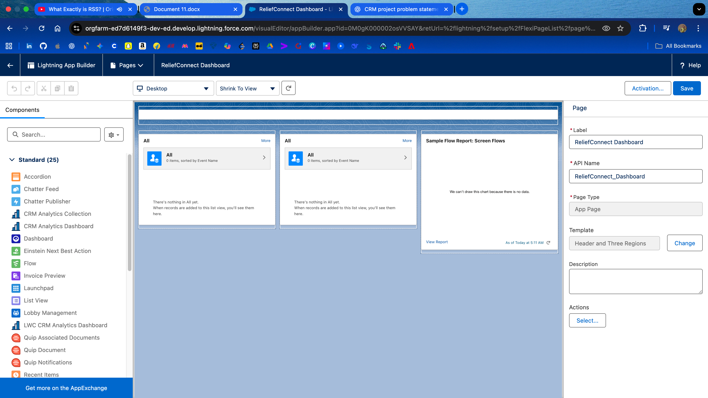

## **4. Record Pages**

Customize layouts for each object:

**Donor__c Record Page**

* Sections: Donor Details, Donation History, Contact Info

**Donation__c Record Page**

* Key Fields: Donation Type, Amount, Status, Related Donor

**Volunteer__c Record Page**

* Minimal layout: Name, Skillset, Availability

**Relief_Request__c Record Page**

* Sections: Disaster Type, Urgency, Needed Items, Status

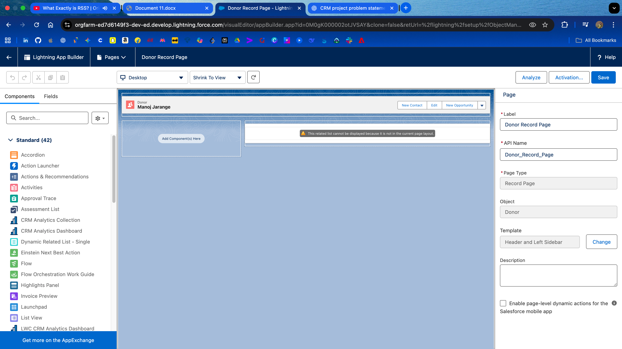

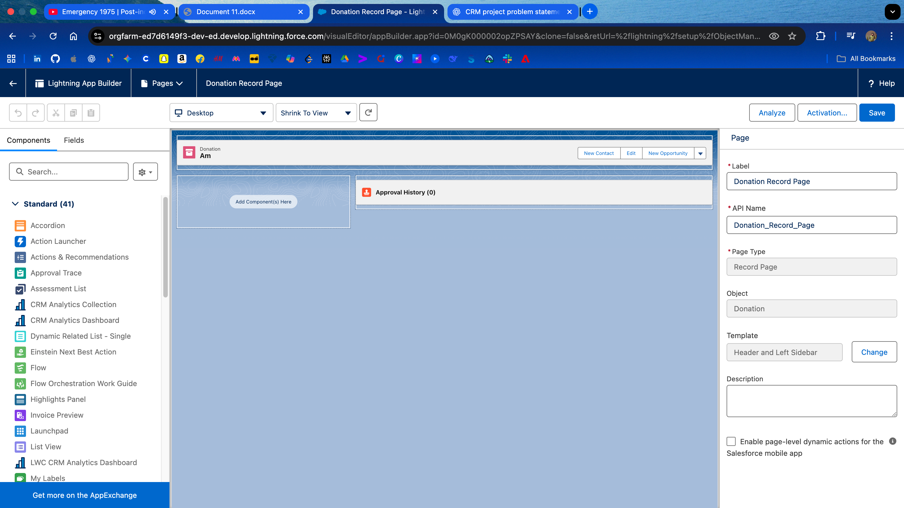

## **5. Tabs**

Navigate: Setup → Quick Find → Tabs → New Custom Object Tab

* Create tabs for: Donors, Donations, Volunteers, Relief Requests, Distributions
* Add icons and set “Default On”

Navigate: App Manager → Edit **ReliefConnect CRM** → Navigation Items → Add Tabs

📸 Screenshot placeholders:

* 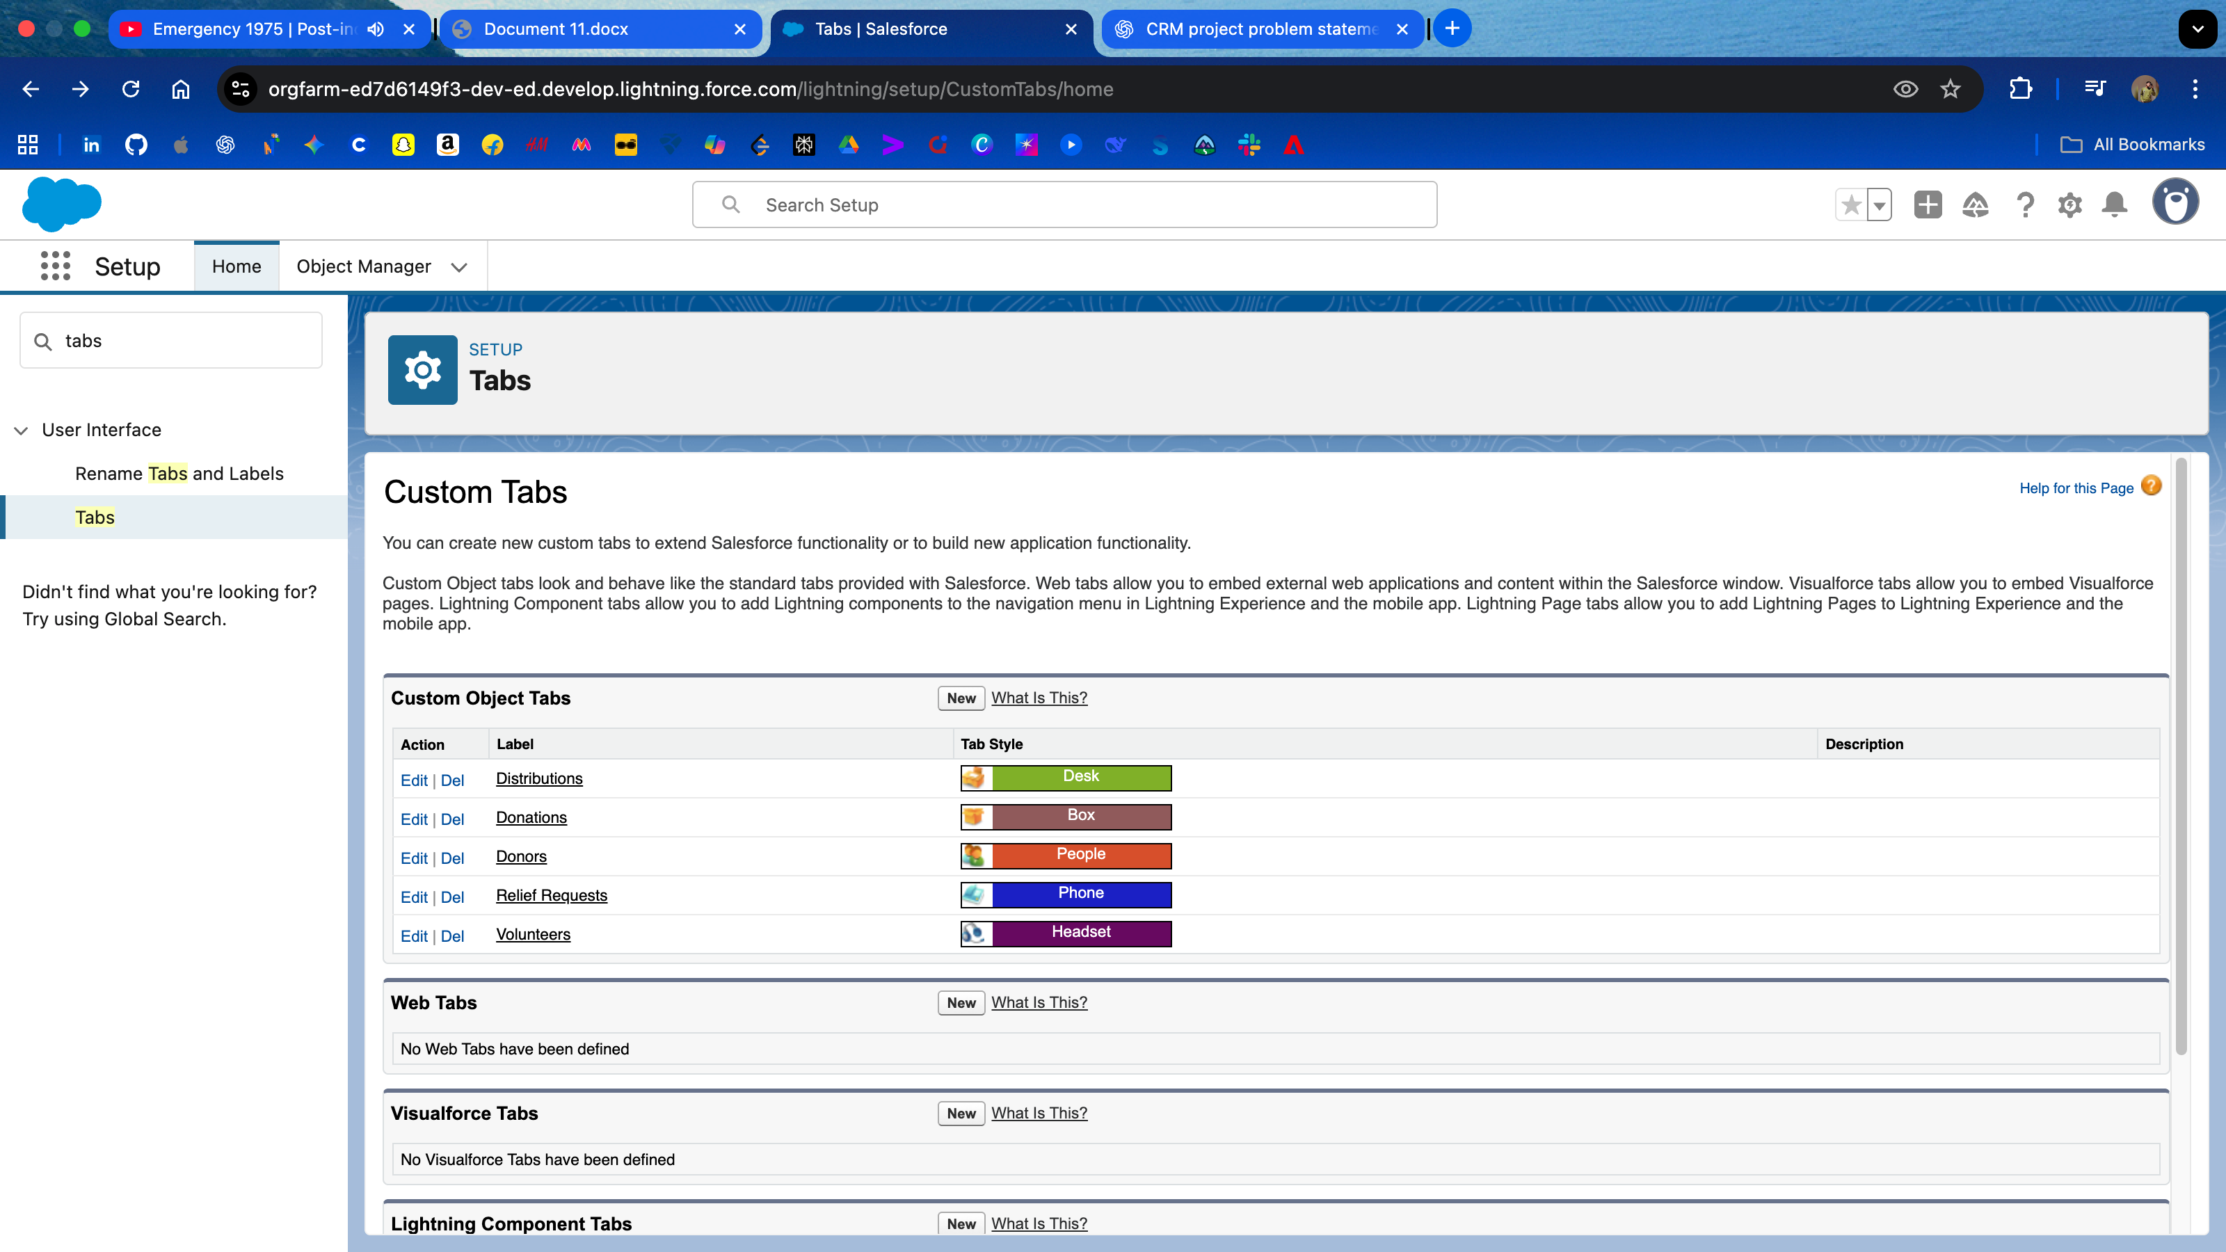

## **6. Utility Bar**

Navigate: App Manager → Edit **ReliefConnect CRM** → Utility Items (Desktop Only) → Add Items:

* Notes (for field updates)
* Recent Items (quick access)
* Report Chart (donation summary)
* To-Do List (assigned tasks for volunteers)

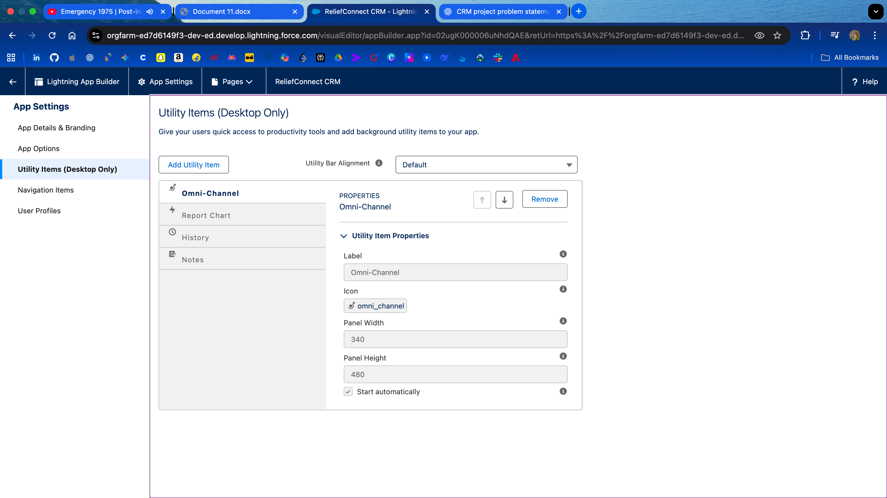

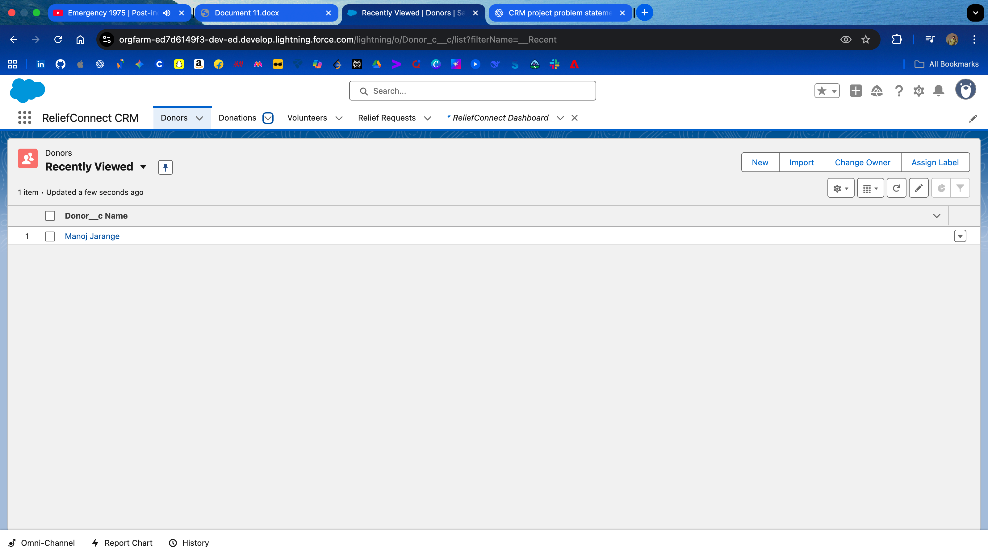

## **7. Lightning Web Component (LWC)**

Create a simple LWC donorImpact:

**donorImpact.html**

<template>  
 <lightning-card title="Donor Impact Dashboard" icon-name="custom:custom63">  
 <p class="slds-p-around_medium">  
 This donor has helped 120 families in Punjab Flood Relief.  
 </p>  
 </lightning-card>  
</template>  
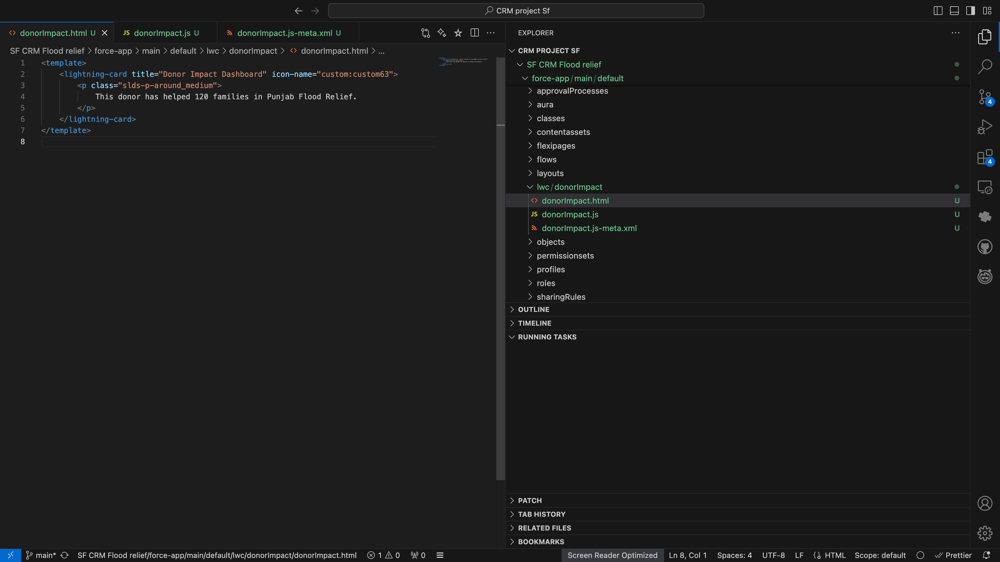

**donorImpact.js**

import { LightningElement } from 'lwc';  
export default class DonorImpact extends LightningElement {}

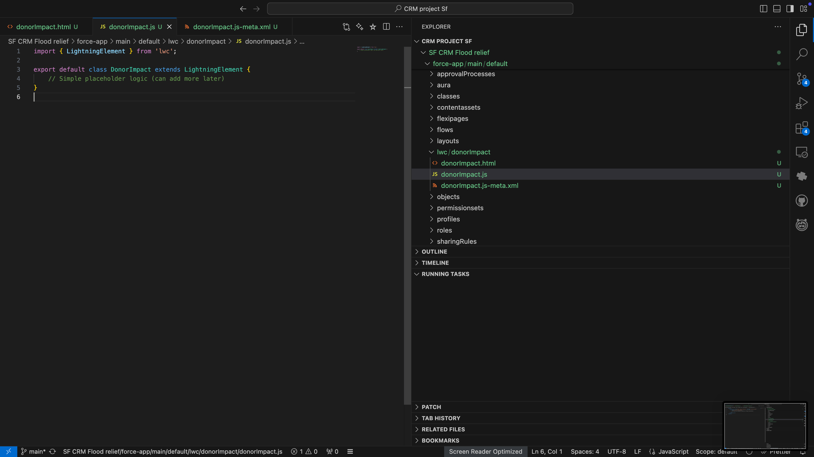

**donorImpact.js-meta.xml**

<?xml version="1.0" encoding="UTF-8"?>  
<LightningComponentBundle xmlns="http://soap.sforce.com/2006/04/metadata">  
 <apiVersion>64.0</apiVersion>  
 <isExposed>true</isExposed>  
 <targets>  
 <target>lightning__RecordPage</target>  
 <target>lightning__AppPage</target>  
 <target>lightning__HomePage</target>  
 </targets>  
</LightningComponentBundle>

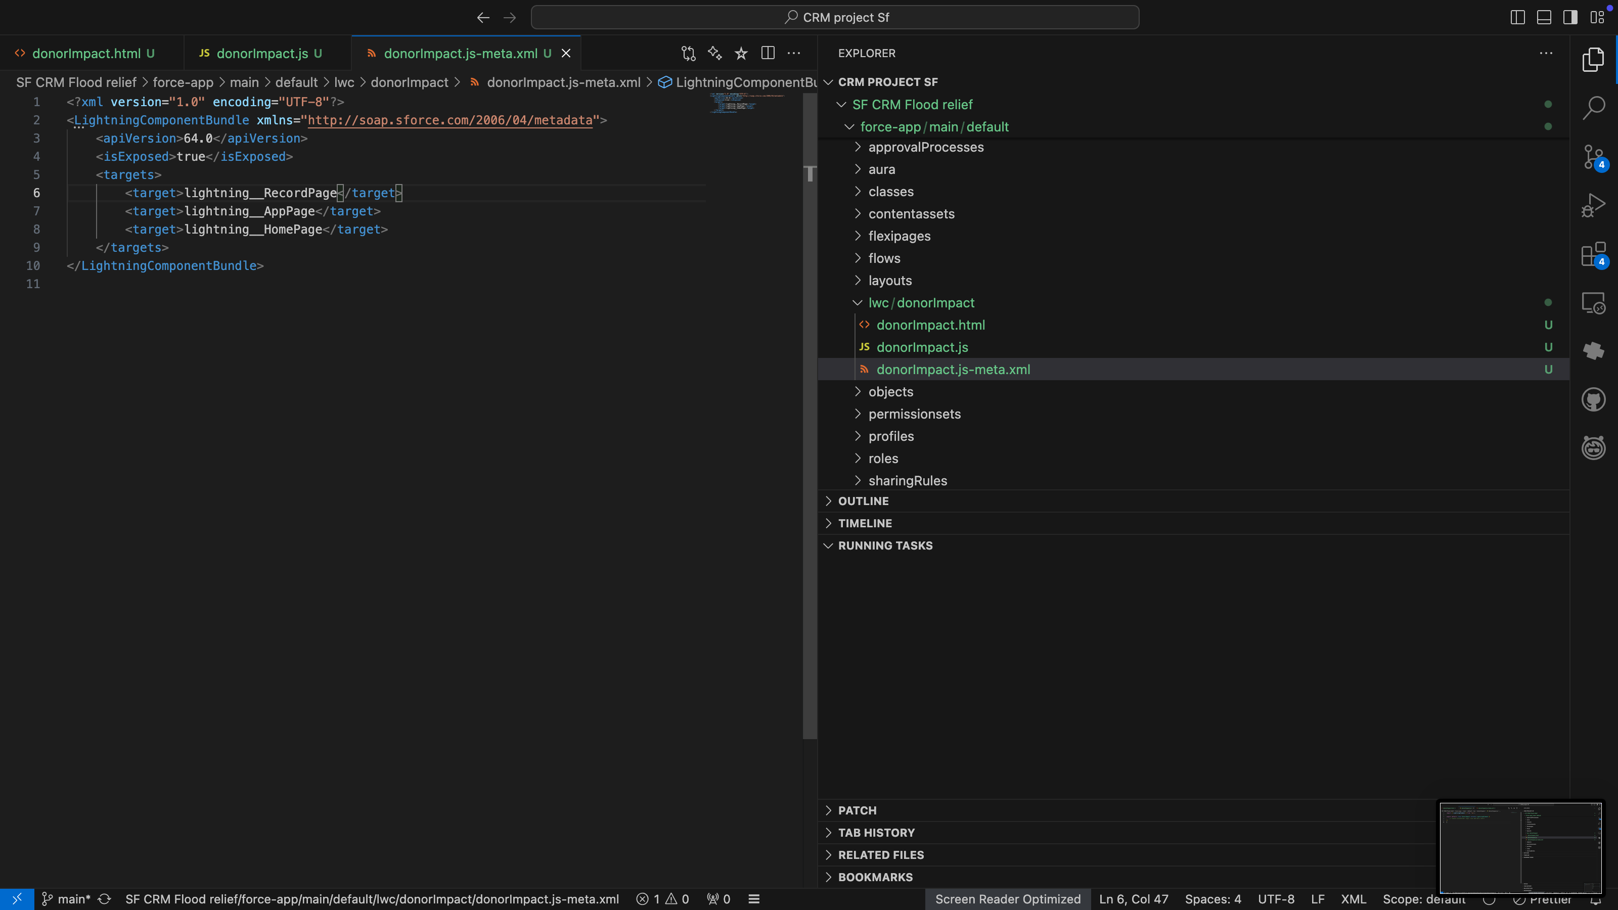

Deploy via VS Code → sf project deploy start --source-dir force-app/main/default/lwc/donorImpact

**8. Phase 6 Conclusion**

With Phase 6 completed, the Punjab Flood Relief CRM now has:

* A custom **ReliefConnect CRM app** with Home Page and Tabs.
* Customized **Record Pages** for each object.
* A **Utility Bar** for quick tools.
* A **Lightning Web Component (donorImpact)** to display donor contribution.

